MOTORCYCLE REGISTRATION  RRVM SPIRIT OF AMERICA BIKE AND CAR SHOW  MAY 8TH-9TH, 2021  Alerus Center Arena 1200 42nd Street South Grand Forks, ND 701-792-1200 | 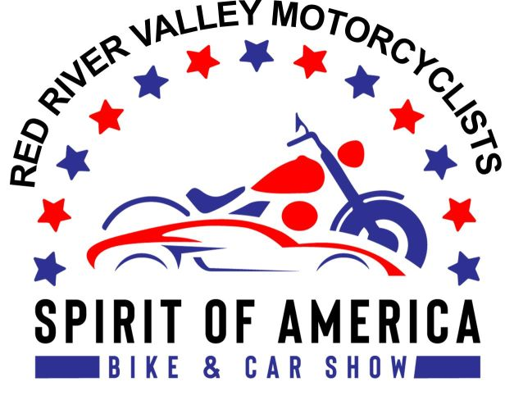

VISIT OUR WEBSITE AT www.rrvmnd.org or the Alerus Center at www.aleruscenter.com
Email inquiries: rrvmnd.org @gmail.com , or call Larry Gaddie 218-779-8510, Tim Gowan 218-695-2082 or Mike Hagen 218-791-2910
IMPORTANT DATE! EARLY MOTORCYCLE ENTRY DEADLINE IS MARCH 31ST, 2021. REGISTER EARLY FOR A CHANCE AT A CASH PRIZE DRAWING! Space sells out quickly so register early!
MOTORCYCLE REGISTRATION FEES: $40.00 per 10'x10' space, if received by March 31ST, 2021. After March 31ST the entry fee is $65 per 10'x10' space. No exceptions! Entry fees are non-refundable. Proceeds are donated to charity. Please provide an email address and we will do our best to contact you to confirm your registration. If you have not heard from us, or have questions about the status of your registration, email us at rrvmnd.org@gmail.com. Entries traveling over 150 miles one way will have their registration fee waived.
ONE MOTORCYCLE PER 10'X10' SPACE: Spots will be pre-assigned in the order in which motorcycle entry forms are received. Additionally, assignments will be determined by motorcycle make, model, and color, so entry photos are required. If your motorcycle (including trailers and display items) cannot fit in one space, you must purchase an additional 10'x10' space(s).
If you wish to exhibit next to another group or individual, please make your preference known on the registration form. Every effort will be made to accommodate your request, but requests are not guaranteed. Groups cannot place more than one motorcycle in an individual 10'x10' space.
PARTICIPANT WRISTBANDS: Registered motorcycle entrants will receive two wristbands per 10'x10' space for admission to the motorcycle show. You MUST wear your wristbands the entire weekend of the show.
ELECTRICITY: If you need electricity for your motorcycle display, a $35 fee must be included with your registration.
CONTACT INFORMATION: Please provide a current phone number (mobile phone preferred) on your registration form so we can contact you in case you are delayed on show set-up . If you have not arrived for show set-up by 9:00 pm and we cannot reach you by phone, you risk forfeiting your bike spot and entry fee. Your space will be sold to entrants on our waiting list.
SET-UP: Friday, MAY 7TH, 2021 from 9:00am to 9:00 pm. No arrivals permitted after 9:00 pm. Set-up is not permitted Saturday morning before the show. No exceptions!
SHOW HOURS: Saturday, MAY 8TH, 2021 from 9 am to 7 pm. Sunday, MAY 9TH, 2021 from 10 am to 4 pm (awards). SHOW ADMISSION: $5.00 for adults. Children ages 10 and younger admitted free with a paying adult. Please make sure to fill out your classification forms and send in with your application!!
MAIL COMPLETED FORM BELOW WITH PAYMENT AND MOTORCYCLE PHOTO TO: RRVM - PO BOX 13864, GRAND FORKS, ND 58208
Please print legibly in the space below
Name_______________________________________________
Mailing Address______________________________________ *Tee Shirt Size Circle one S M L XL XXL XXXL
City State/Province Zip or Postal Code
Phone Email Address
Motorcycle Year/Make/Model/Color/CC
Registration Fee: $40 per 10'x10' space # of spaces needed $
$65 per space after March 31ST, 2021 Electricity Needed: $35 fee for hookup (Circle one) Yes/no For Internal Use Only: TOTAL AMOUNT ENCLOSED $
Date Rec’d
Amount Rec’d By submitting my registration I agree to abide by the show rules.
Pmt # Spot#___________ Booth tear down is not permitted before the awards ceremony

