CAR REGISTRATION  RRVM SPIRIT OF AMERICA BIKE AND CAR SHOW  MAY 8TH-9TH, 2021  Alerus Center Arena 1200 42nd Street South Grand Forks, ND 701-792-1200 | 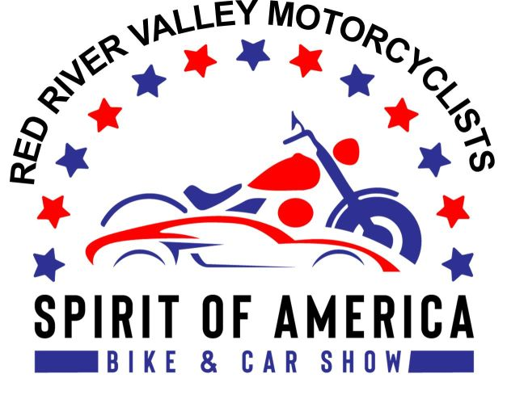

VISIT OUR WEBSITE AT www.rrvmnd.org or the Alerus Center at www.aleruscenter.com
Email inquiries: rrvmnd.org @gmail.com , or call Lanny Moore 218-779-5530 Al Vein 701-740-4574
IMPORTANT DATE! EARLY CAR ENTRY DEADLINE IS MARCH 31ST, 2021. REGISTER EARLY FOR A CHANCE AT A CASH PRIZE DRAWING! Space sells out quickly so register early!
CAR REGISTRATION FEES: $40.00 per space, if received by March 31ST, 2021. After March 31ST the entry fee is $65 per space. No exceptions! Entry fees are non-refundable. Proceeds are donated to charity. Please provide an email address and we will do our best to contact you to confirm your registration. If you have not heard from us, or have questions about the status of your registration, email us at rrvmnd.org@gmail.com. Entries traveling over 150 miles one way will have their registration fee waived.
ONE CAR IN SPACE: Spots will be pre-assigned in the order in which car entry forms are received. Additionally, assignments will be determined by car make, model, and color, so entry photos are required. If your car (including trailers and display items) cannot fit in one space, you must purchase an additional space.
If you wish to exhibit next to another group or individual, please make your preference known on the registration form. Every effort will be made to accommodate your request.
PARTICIPANT WRISTBANDS: Registered car entrants will receive two wristbands per space for admission to the bike and car show. You MUST wear your wristbands the entire weekend of the show.
ELECTRICITY: If you need electricity for your car display, a $35 fee must be included with your registration.
CONTACT INFORMATION: Please provide a current phone number (mobile phone preferred) on your registration form so we can contact you in case you are delayed on show set-up . If you have not arrived for show set-up by 9:00 pm and we cannot reach you by phone, you risk forfeiting your car spot and entry fee. Your space will be sold to entrants on our waiting list.
SET-UP: Friday, MAY 7TH, 2021 from 9:00am to 9:00 pm. No arrivals permitted after 9:00 pm. Set-up is not permitted Saturday morning before the show. No exceptions!
SHOW HOURS: Saturday, MAY 8TH, 2021 from 9 am to 7 pm. Sunday, MAY 9TH, 2021 from 10 am to 4 pm (awards). SHOW ADMISSION: $5.00 for adults. Children ages 10 and younger admitted free with a paying adult.
MAIL COMPLETED FORM BELOW WITH PAYMENT AND MOTORCYCLE PHOTO TO: RRVM - PO BOX 13864, GRAND FORKS, ND 58208
Please print legibly in the space below
Name_______________________________________________
Mailing Address______________________________________ *Tee Shirt Size Circle one S M L XL XXL XXXL
City State/Province Zip or Postal Code
Phone Email Address
Car Year/Make/Model/Color/CC
Registration Fee: $40 per space # of spaces needed $
$65 per space after March 31ST, 2021
Electricity Needed: $35 fee for hookup (Circle one) Yes No $
For Internal Use Only: TOTAL AMOUNT ENCLOSED $
Date Rec’d
Amount Rec’d By submitting my registration I agree to abide by the show rules.
Pmt # Spot#___________ Booth tear down is not permitted before the awards ceremony

