VENDOR REGISTRATION  RRVM SPIRIT OF AMERICA BIKE AND CAR SHOW  MAY 8TH-9TH, 2021  Alerus Center Arena 1200 42nd Street South Grand Forks, ND 701-792-1200 | 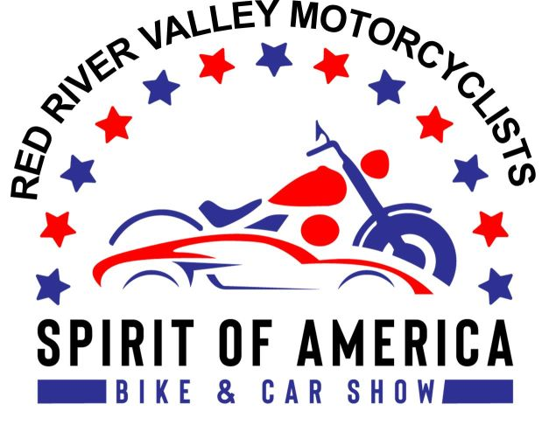

VISIT OUR WEBSITE AT www.rrvmnd.org or the Alerus Center at www.aleruscenter.com
Email inquiries: rrvmnd.org @gmail.com, or call Larry Gaddie 218-779-8510, Tim Gowan 218-695-2082.
IMPORTANT DATE! EARLY REGISTRATION DEADLINE IS MARCH 31, 2021. REGISTER EARLY FOR A CHANCE AT A CASH PRIZE DRAWING! Vendor spots will be per-assigned in the order in which vendor registration forms are received. Space sells out quickly so register early!
VENDOR REGISTRATION FEES: $300 per 10'x10' space. 5OO/SQ feet and larger is $2 a square foot If received by March 31st, 2021. An additional $50 fee per spot applies for late registrations! Motorcycle, car entry and vendor fees are non-refundable. Proceeds are donated to charity.
Please provide an email address and we will do our best to contact you to confirm your registration. If you have not heard from us, or have questions about the status of your registration, email us at rrvmnd.org@gmail.com.
VENDOR WRISTBANDS: Registered vendors will receive two wristbands per 10'x10' space. 500/sq feet and bigger will receive more on request. You MUST wear your wrist band’s the entire weekend of the show to enter the Alerus Center Arena or you will be charged admission.
ELECTRICITY: If you need electricity for your vendor booth, a $35 fee must be included with your registration.
INTERNET OR PHONE LINE: If you need a phone line for an Internet connection, contact the Alerus Center directly at 701-792-1200 for rates per day, and to establish a connection at your own expense. Pay the Alerus Center directly for this service.
TABLES AND CHAIRS: Provide by RRVM 1 table and 2 chairs for vendor booths. If you have your own, bring them.
ATTENTION: Non-profit or civic organizations with multiple volunteer staffers in one 10'x10' space must attach a list of no more than SIX names of booth volunteers. Additional volunteers or those not on the list will be required to pay the $5.00 admission fee to enter the motorcycle & car show. NO EXCEPTIONS. This requirement applies only to non-profit and civic organizations.
VENDOR SET-UP: Friday, May 7th, 2021 from 9:00am to 9:00pm. No arrivals permitted after 9:00pm. SHOW HOURS: Saturday, May 8th from 9 am to 7 pm. Sunday, May 9th from 10 am to 4 pm (awards). SHOW ADMISSION: $5.00 for adults. Children ages 10 and younger admitted free with a paying adult.
MAIL COMPLETED FORM BELOW WITH PAYMENT TO: RRVM - PO BOX 13864, GRAND FORKS, ND 58208
Please print legibly in the space below
Business Name or Organization
Business/Organization Website
Contact Person Staffed Booth? (Circle one) Yes No
Phone Email Address
Mailing Address
City State/Province Zip or Postal Code
Vendor Registration Fee: $300 per 10'x10' space # of spaces needed $
$350 per space after March 31st, 2021
Electricity Needed: $35 fee for hookup (Circle one) Yes No $
For Internal Use Only:  Date Rec’d  Amount Rec’d  Pmt # Spot#___________ | TOTAL AMOUNT ENCLOSED $
By submitting registration I agree to abide by the show rules.
Booth tear down is not permitted before the awards ceremony

